360 Boyz Secure
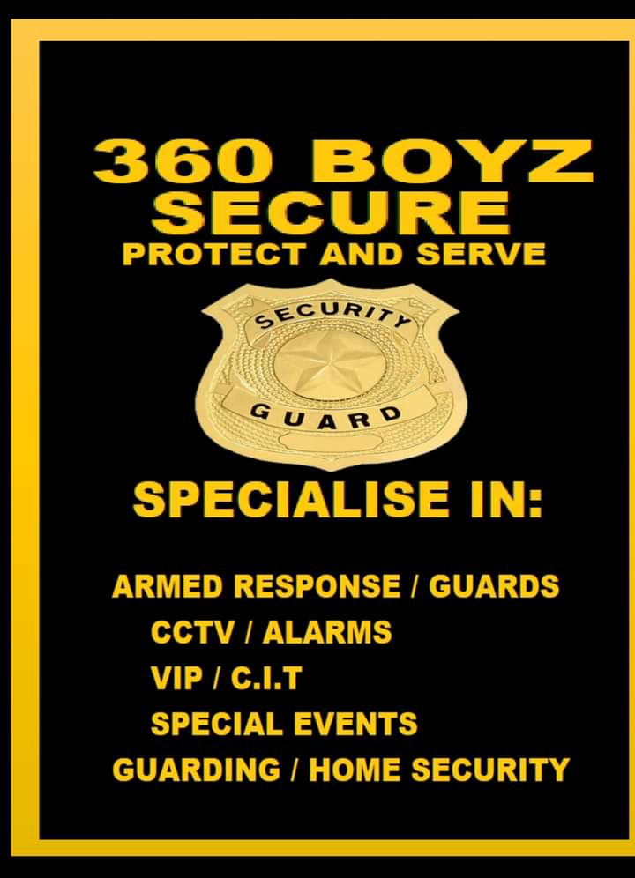
Name and ST Bertha Nair ST10510907
Module Name Web Development
Program and Module Code DISD0601
WEDE5020
Group N.O Group 1
Assignment Proposal.IceTask

Table of Contents
Organisation Overview 1
Mission 1
Vision 1
Target Audience 1
Website Goals and Objectives 2
Website Goals 2
Key Performance Indicators (KPIs) 2
Current Website Analysis (if applicable) 3
Proposed Website Features and Functionality 3
Design and User Experience 4
Colour Scheme: Proposed Colour Palette 4
Typography: Font Choices and Hierarchy 4
Layout and Design 5
User Experience Considerations 5
Low-Fidelity Wireframes 5
Technical Requirements 6
Timeline and Milestones 7
Budget 7
References 8

Organisation Overview
- Name: 360 Boyz Secure
360 Boyz Secure was incorporated in South Africa on 3 May 2019. Foundered by Preshu Singh the company initially established its roots on Smith Street in Dundee before growing its local presence. Over the years, the firm expanded from a local security outfit into a broader vendor of technical services, earning an AA Qualified approved technical services member status with operations at 4 Avon Road in Dundee.
The company grew its reputation by addressing multi-dimensional protection needs in the Umzinyathi District. They diversified their traditional physical guarding options into comprehensive tactical operations and electronic surveillance installations.
As an accredited security company, 360 Boyz Secure is focused on protecting people, businesses, and communities.

Mission
360 Boyz Secure’s mission is to provide high-quality, affordable, and reliable security services. The company aims to give clients peace of mind by offering different security solutions, including VIP protection, security guarding, CCTV installation, and private investigations.

Vision
360 Boyz Secure’s vision is to be a trusted, all-round security company that protects people, businesses, and communities. The company aims to provide professional security services while also working with local communities to help prevent crime and create a safer environment across KwaZulu-Natal.

Target Audience
360 Boyz Secure’s target audience includes people and businesses that need security and protection.
- Businesses: Companies that need security guards, CCTV, and protection for their property and workers.
- Homeowners and families: People who want to keep their homes, families, and belongings safe.
- VIPs and important people: People who need personal protection and security.
- Shops and commercial businesses: Stores, offices, warehouses, and other businesses that need protection from theft and crime.
- Communities and organisations: Schools, events, and community groups that need help with safety and crime prevention.
- People who need investigations: Individuals and businesses that need private investigation services.

Website Goals and Objectives
The main goal of the 360 Boyz Secure website is to tell people about the company and help them easily get security services.

Website Goals
- Get more customers: Help more people find and use the company’s services.
- Create awareness: Let people know about 360 Boyz Secure and what it offers.
- Get more enquiries: Encourage people to contact the company for more information.
- Build trust: Show that the company is professional, reliable, and focused on keeping people safe.
- Explain the services: Clearly show services such as security guards, CCTV, VIP protection.
- Make it easy to contact the company: Allow customers to call, email, or send a message through the website.

Key Performance Indicators (KPIs)
The website’s success can be measured by:
- Number of visitors: How many people visit the website.
- Number of enquiries: How many people contact the company.
- Number of quote requests: How many people ask for a price.
- Number of phone calls: How many people call the company from the website.
- Contact forms: How many people complete the contact form.
- Social media visits: How many people click on the company’s social media pages.
- New customers: How many website visitors become customers.
- Google ranking: How easily people can find the company on Google.
The main objective is to use the website to attract new customers, build trust, explain the company’s services, and make it easy for people to contact 360 Boyz Secure.

Current Website Analysis (if applicable)
360 Boyz Secure does not have an official website and has a limited social media presence. However, the company is well known and trusted in the local community. This is a strength because it gives the company a good reputation. But it does have a website under AA Qualified approved technical services.
The main weakness is that people cannot easily find information about the company and its services online. The company could improve by creating a simple, professional website with information about its services, contact details, company background, and customer reviews. Improving its social media presence would also help the company reach more customers and grow its business.

Proposed Website Features and Functionality

The website should be simple, professional, and easy to use. It should give visitors clear information about 360 Boyz Secure and make it easy for them to contact the company.
- Home Page: Introduce the company and show its main security services.
- About Us: Give information about the company, its experience, values, and goals.
- Services Page: Show the different services offered, such as security guards, CCTV, VIP protection
- Contact Page: Include the company’s phone number, email, location, and a contact form.
- Request a Quote: Allow customers to ask for a price for a security service.
- Gallery: Show photos of the company, staff, security equipment, and work.
- Social Media Links: Connect the website to the company’s social media pages
- Simple Navigation: Visitors should be able to easily find information and move between pages.

Design and User Experience
The proposed website for 360 Boyz Secure will have a professional, modern, and trustworthy design that reflects the company’s security services and existing branding. The design will focus on making valuable information easy to find while creating a strong first impression for potential clients.

Colour Scheme: Proposed Colour Palette
The main colours will be black, yellow/gold, and white, based on the company’s existing logo and promotional material.
- Black: Used as the main background colour to create a strong and professional appearance.
- Yellow/Gold: Used for headings, buttons, borders, and valuable information to match the company branding.
- White: Used for the main text and content areas to provide clear contrast and improve readability.

Typography: Font Choices and Hierarchy
A simple, modern sans-serif font such as Arial or Aptos will be used. Large, bold headings will be used for page titles, while smaller headings will separate different sections. Normal-sized text will be used for descriptions and service information. This hierarchy will make the website easier to read and navigate.

Layout and Design
The website will use a clean and responsive layout that works on computers, tablets, and mobile phones. The homepage will have the 360 Boyz Secure logo, slogan “Protect and Serve”, a short introduction and clear buttons directing users to the services and contact pages.
The main navigation will include:
Home | About Us | Services | Gallery | Contact Us
Service cards will be used to display the main services, including Armed Response/Guards, CCTV/Alarms, VIP/C.I.T, Special Events, Guarding and Home Security.

User Experience Considerations
The website will have simple navigation so users can quickly find the information they need. Contact details and a “Request a Quote” button will be clearly visible. The colour scheme will provide good contrast, while the responsive design will ensure that the website stays easy to use on different screen sizes.
360 BOYZ SECURE LOGO HOME ABOUT SERVICES CONTACT
────────────────────────────────────────────
PROTECT AND SERVE
Reliable Security Solutions

[ REQUEST A QUOTE]
────────────────────────────────────────────
OUR SERVICES
[Armed Response] [CCTV/Alarms] [VIP/CTI]
│ [Special Events] [Home Security] [Guarding]
─────────────────────────────────────────────
WHY CHOOSE US?
Professional | Reliable | Local

─────────────────────────────────────────────

CONTACT US
Phone | Address | Contact Form

Low-Fidelity Wireframes
Homepage

Services Page
360 BOYZ SECURE NAVIGATION
─────────────────────────────────────────────

OUR SERVICES
─────────────────────────────────────────────

[ARMED RESPONSE / GUARDS]
Description of service

[CCTV / ALARMS]
Description of service

[VIP / C.I.T]
Description of service

[SPECIAL EVENTS / HOME SECURITY]
Description of service
─────────────────────────────────────────────

[ REQUEST A QUOTE] [ CONTACT US]

Technical Requirements
The 360 Boyz Secure website will require reliable web hosting and a professional.co.za domain name. The website will use HTML for structure, CSS for styling, and JavaScript for interactive features.
GitHub for version control and Bas search engine optimisation.

Timeline and Milestones
- August 3-5: Research 360 Boyz Secure and identify the website requirements.
- August 5-6: Plan the website structure, pages and content.
- August 7-9: Create the colour scheme, typography and low-fidelity wireframes.
- August 9-14: Work on part one submit part one
- August 16-31: Begin developing the website using HTML, CSS and JavaScript.
- September 1- 10: Add company information, services, images and contact features.
- September 10- 17: Test the website on different devices and fix any errors.
- September 17: Complete final changes, proofreading, and testing.
- Submission Week: Review the completed project and submit it before the subject deadline.

Budget
- Website development: R3 000 – R5 000
- Domain name (.co.za): About R150 per year
- Web hosting: About R600 – R1 000 per year
- SSL certificate: Free with most hosting providers.
- Maintenance: About R300 – R500 per month.
- Estimated first-year budget: Approximately R7 350 – R12 150.

References
- 360 Boyz Secure. (2026). 360 Boyz Secure Facebook page. Facebook. Available at: 360 Boyz Secure on Facebook⁠
  - Used to research the company’s services, including CIT, VIP protection, guarding, CCTV, alarm systems, private investigations, missing persons and community work.
- AA Quality Assured. (2026). 360 Boyz Secure – Vendor Listing. Available at: AA Quality Assured⁠
  - Used to verify that 360 Boyz Secure is listed as a vendor in Dundee and to obtain its business contact information.
- Google Search/Google Business information. (2026). 360 Boyz Secure business listing. Google.
  - Used to research the company’s location, contact details and business information.
- Mozilla Developer Network (MDN). (2026). HTML, CSS and JavaScript documentation. Available at: https://developer.mozilla.org/

